**Job Folder Training**

# The purpose of job folder documentation

### The purpose of job folder documentation is provide digital files with sortable metadata that will imporve the searchability and location of hosted documents.

## What job folder documents are

### Job Folder documents are part of the Conrad Blucher Map Collection. They contain everything from field notes to correspondance to legal descriptions of the many surveying projects the Blucher family was a part of.

## Why they need to be documented

### When these documents are made publicly available through a digital archive they will need to be sortable. With over 20,000 documents in the collection, the metadata we extract and digitally document we will vastly improve the research value of the collection.

# Documentation Procedures

### A standard operating procedure has been developed to provide consistency when digitizing and indexing Job Folder documents. Adherance of these procedures is paramount to the quality and navigability of our documents and their database.

## Scanners

### We currently operate using two scanners, a 42” pass through scanner which handles large prints (i.e. maps, blueprints, plats, & tracings) and a 12.2” x 17.2” flatbed scanner to handle everything from notes to legal sized sheets. Each scanner has its own operating procedures which will be available to the operators.

## Titling

### Specific document titling procedures is the most important part of our documentation. The titling procedures allow the database to automatically sort and store documents when they are uploaded, it also automatically connects front and backs of documents in the database. The titling format is not a recommendation, if there are any questions or outstanding circumstances that prevent you from following procedure, contact the lab coordinator at once. Do not upload the document, do not pass go, and do not collect $200.

## Scanning

### Before document scannign begins, it is important to ensure scan settings are correctly set. A detailed procedure is set in place and the latest version can always be found on the job folder section of the database.

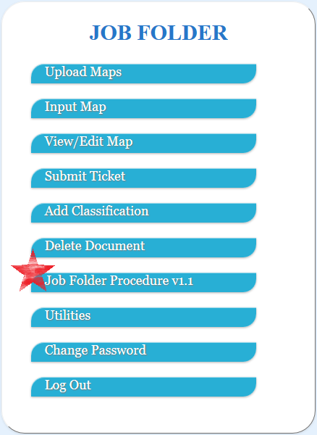

## Editing

### There are two approved document editing programs for Job Folder documents. The first is the autocropping program built in-house. This software only works with documents scanned on the flatbed scanner. The procedures for using this program are found in the latest version of the Job Folder procedures. The other program is Microsoft Office. This photo editing software is used to crop and rotate documents scanned on the large format scanner when the scanning software (ScanWorks) fails to edit properly do to glitches. If a document requieres more than cropping and rotating to be fixed, the document needs to be rescaned. Glitches from the scanners or their software cannot be overlooked and documents must be rescaned.

# Document Types

### There are several classifications used when documenting that provide end users with ‘catergories’ that help filter searches. The following are those classifications and their descriptions.

## Field Note

### An actual page from a field book or a typed report of field book notes. They are often titled ‘Field Notes’ or is a list of survey point information.

## Survey Calculation

### Recorded arithmetic pertaining to a survey. Often contains sketches and on yellow legal paper.

## Legal Document

### Typed and signed documents pertaining to a survey, land tenure or sale, or work contract. Often contains an official stamp or notary.

## Map/Blueprint

### This classification only pertains to large sized maps, smaller map draft will be classified as ‘Survey Calculation’ because they are considered a sketch.

## Folder Cover

### A scanned copy of the original Job Folder.

## Separation Sheet

### An index sheet provided by the Mary & Jeff Bell Library at Texas A&M University – Corpus Christi denoting a document who’s physical condition is too poor to be scanned. The original map or document can only be accessed on-site in person.

## Envelope/Binding

### Can classify anything from an envelope to a taped piece of paper used to bind documents. Envelopes and bindings that are blank and contain no information are not scanned.

## Note

### A document that contains minimal information and cannot be otherwise classified.

## Stencil

### A document that is used to replicate specific fonts, symbols, or texts.

## Legal Document Draft

### A legal document that has not be officiated, or contains review marks.

## Correspondence

### A document that appears to be conversation. Often an official telegram, but can still be messages left at hotels or offices for the surveyor or another contact.

## Legal Description

### A document which is a written geographical description of a property for the purpose of identifying the property for legal transactions.

# Documentation Examples

### For a visual reference of examples and extracted metadata please refer to the ‘[Job Folder Training Examples](Job%20Folder%20Training%20Examples.pptx)’ powerpoint. This document will show documents and their webpage on the database side by side and highlight where information was extracted from. these examples reflect more common formats, but do not assume every document of that classification will be the same.

# Common Errors

### Perfectly inputted metadata is the goal, but in reality the non-repetative nature of Job Folder documentation results in small error from time to time. A few common errors that often occur are:

Forgetting to adjust the name of a document when scanning its back. Our scan software works with automatic counters for the names of the documents and some manual adjustments must be made.

not adding sub folder comments to documents that are in sub folder, or putting the sub fodler comments in the classification comments section.

Mistitling documents that fall into subfolders.

Adding proper comments such as job numbers or scale information in the general comments sectiong.